Electric Service Credit Union
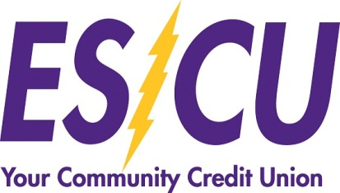
Checking Account Fee Comparison

 | Basic/Free Checking | Student Checking | Interest Rewards Checking
 |  | (ages 15-24)
ATM Fee Refund (Up to $10 monthly) | NO | YES | YES (if qualifying criteria met)
ATM/Debit Card | YES | YES (Under 18, guarantor required) | YES (required 10 signature/non-PIN transactions)
Courtesy Pay | AVAILABLE | AVAILABLE | AVAILABLE
Direct Deposit | YES | YES | YES (1 per month required)
Dividends Earned | NO | NO | YES (if qualifying criteria met)
E-Statement | YES | YES | YES (required)
Minimum Balance Required After Opening Acct | NO | NO | NO
Mobile Deposit | YES, Free | YES, Free | YES, Free
Mobile Money/Mobile Banking | YES, Free | YES, Free | YES, Free
Monthly Service Charge | NO | NO | NO (if qualifying criteria met)
Monthly Statement | YES | YES | YES (required)
Online Bill-Pay | Free if at least 6 bills paid, otherwise $5.95 monthly | Free if at least 6 bills paid, otherwise $5.95 monthly | Free if at least 6 bills paid, otherwise $5.95 monthly
Overdraft Protection | FREE (If available in savings) | FREE (If available in savings) | FREE (If available in savings)
Pop Money (Person to Person Mobile Payments) | YES | YES | YES
Unlimited Check Writing | YES | YES | YES
Virtual Branch/Online Banking | YES, Free | YES, Free | YES, Free

